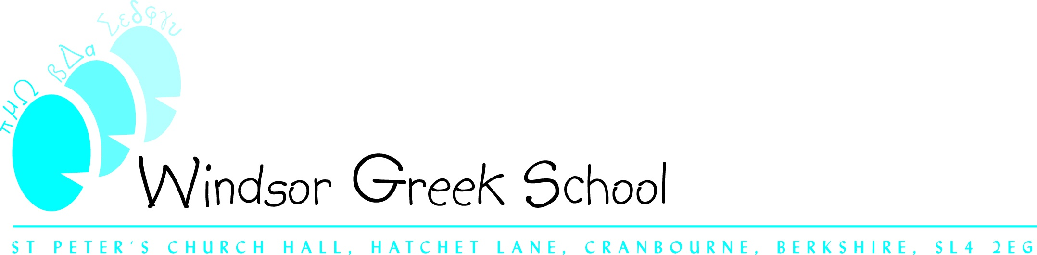

Dear All,

The Greek school has arranged a very casual, spontaneous night-out to catch up with those of you we already know and to welcome any new families.

Venue: La Barca Restaurant and Tapas Bar, The Boathouse, Thameside, Henley RG9 1AZ (tel: 01491-577937)

When: Saturday 12th November at 8pm

You can get more information about menues and prices from La Barca's website (labarcahenley.co.uk).

Please let me know by Wednesday 9th November if you will be able to join us as I will need to give the restaurant a final booking number.

We apologise for the very short notice and appreciate that not all of you will be able to make it. We will be planning another social event for the parents shortly after Christmas.

We hope to see as many of you as possible!

Regards,

Sarah Vergopoulos

greekschool footer.jpg